Time to Act Data Navigator – Communication Materials

This document contains suggested social media publications for the launch of the ‘Time To Act’ Data Navigator Upgrade, along with their Key messages. The messages are adapted to Facebook, LinkedIn and Twitter channels.

Message | Post | Visual
Message 1: It is time to address structural and systemic vulnerability of healthcare systems exposed by the Covid-19 pandemic to build back more resilient and sustainable cancer care in the long-term. | For Facebook and LinkedIn:  The #Covid19 pandemic has deeply affected the screening and treatment of all types of cancer across Europe, exposing vulnerabilities in #CancerCare.  The @European Cancer Organisation’s #DataNavigator displays some of the most significant burden on European countries in numbers 👉 http://timetoactcancer.com/data-navigator  We should all learn the lessons and build more sustainable cancer care systems for the future⏩ 🏥  #TimeToActCancer  For Twitter:  The @EuropeanCancer #DataNavigator displays some of the most significant burden on European countries in numbers 👉 http://timetoactcancer.com/data-navigator  We should all learn the lessons and build more sustainable cancer care systems for the future⏩ 🏥  #TimeToActCancer | 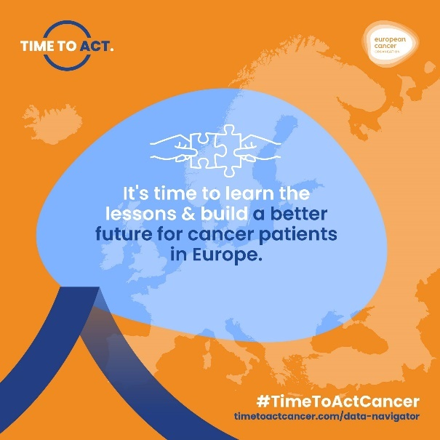
Message 2: The Covid-19 pandemic has impacted every cancer type and every healthcare system differently. It is time to address the cancer backlog and disparities in cancer care systems’ recovery across Europe. | For Facebook and LinkedIn:  Regardless of cancer type or country, data shows that #Covid19 has disrupted #CancerCare across Europe 🌍  Use the @European Cancer Organisation’s #DataNavigator to discover the cancer backlog from 🇦🇹 to 🇸🇮. 👉 http://timetoactcancer.com/data-navigator  Together, it’s #TimeToAct and address the disparities in cancers systems recovery, building a better future for #CancerPatients in Europe❗  For Twitter:  Use the @EuropeanCancer’s #DataNavigator to discover the cancer backlog from 🇦🇹 to 🇸🇮. 👉 http://timetoactcancer.com/data-navigator  Together, it’s #TimeToAct and address the disparities in cancers systems recovery, building a better future for #CancerPatients in Europe❗ | 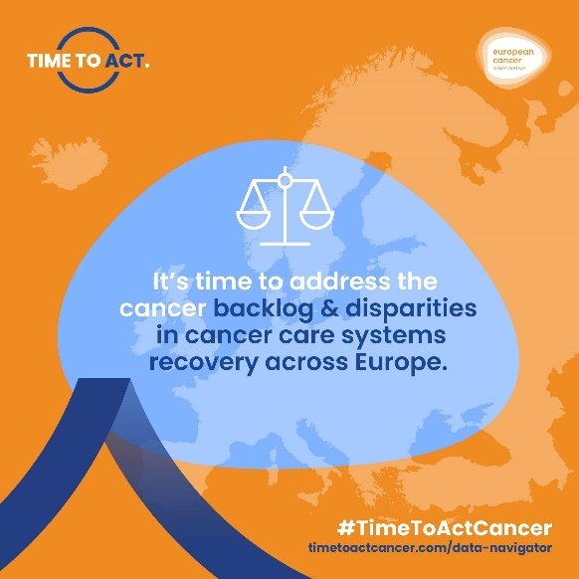
Message 3: The ‘Time To Act’ Data Navigator is a unique living tool that will serve to help assess year by year trends in cancer care service delivery across Europe to inform policy action needed to address main challenges and gaps. | For Facebook and LinkedIn:  The @European Cancer Organisation ’s #DataNavigator 🔎 🗺️ is a unique interactive tool, helping to:  ▶️ assess cancer backlog and disparities in cancer systems recovery across Europe  ▶️ inform policy action to address challenges and gaps in cancer care delivery  Using this tool, we can better understand the impact of #Covid19 on cancer and how to build more resilient #CancerCare systems for the future 💪🏥 http://timetoactcancer.com/data-navigator  You can help this living tool evolve, ensuring that it encompasses more and more #data!  For Twitter:  The @EuropeanCancer's #DataNavigator is a unique interactive & constantly evolving tool, helping to  ▶️assess cancer backlog & disparities in #CancerSystems recovery across Europe  ▶️inform policy action to address challenges & gaps  Make your data count👉 http://timetoactcancer.com/data-navigator | 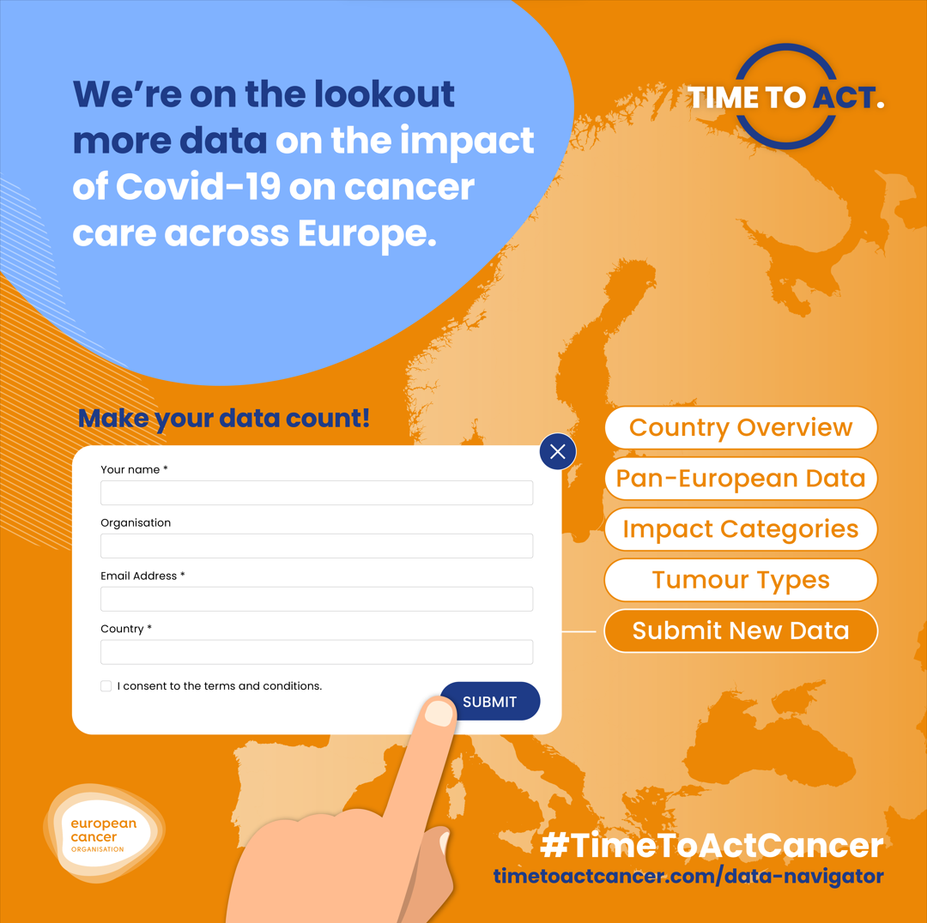
Message 4: We need to ensure the wider collection of data on the impact of Covid-19 on cancer care. Help us collect more data and make your data count. | For Facebook and LinkedIn:  Do you know how #Covid19 has impacted #CancerCare in your country❓  Data on the impact on #CancerPatients and their care due to Covid-19 remains scarce, but it is key 🔑 to address the #CancerBacklog in #HealthcareSystems 🏥.  Together, we can complete the picture and ensure that data on the impact of Covid-19 on cancer is widely collected across Europe.  Got data on your country? Share it with the @European Cancer Organisation 👉 https://www.europeancancer.org/data-navigator/submit-data  #DataNavigator #TimeToActCancer  For Twitter:  Do you know how #Covid19 has impacted #CancerCare in your country❓  Together with @EuropeanCancer, we can complete the picture & ensure that data on the impact of Covid-19 on #Cancer is widely collected across Europe👉 https://www.europeancancer.org/data-navigator/submit-data  #DataNavigator #TimeToActCancer | 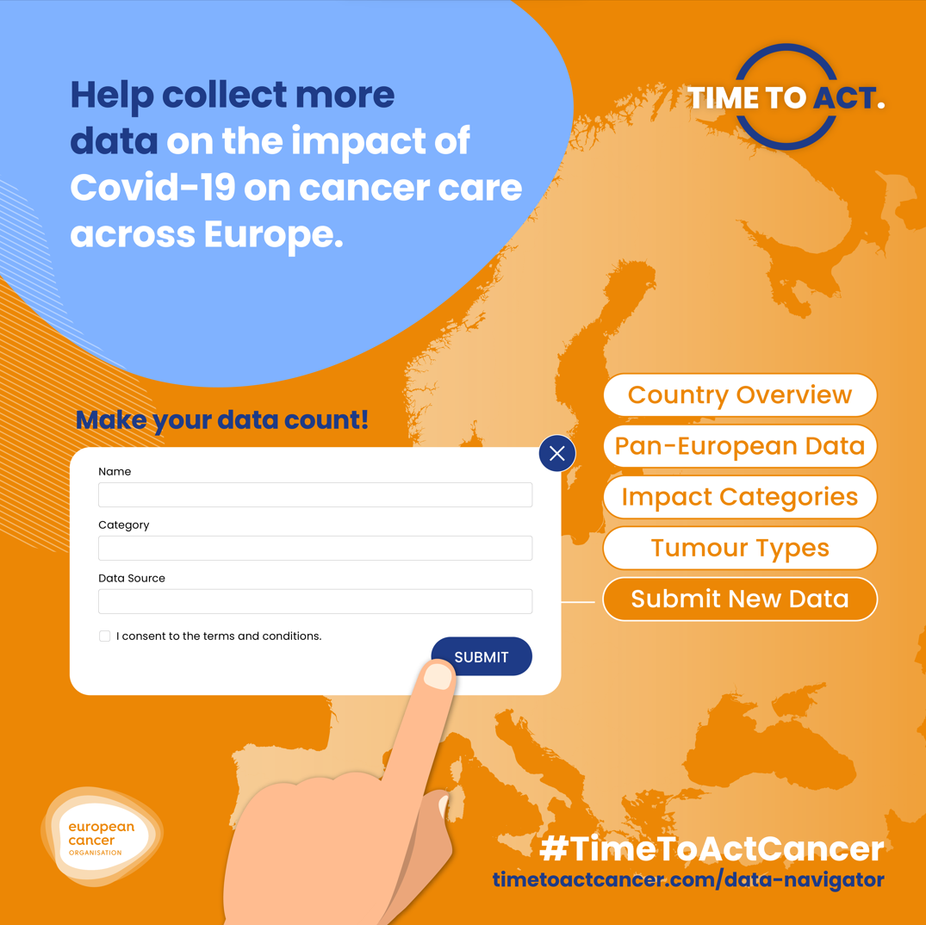
Message 5: It is time to restore the confidence of European citizens and cancer patients in cancer care services post-Covid-19. | For Facebook and LinkedIn:  Disruptions to screening tests🔎 and missed diagnoses🩺 due to #Covid19 have significantly impacted #CancerPatients and #CancerCare 📉.  The @European Cancer Organisation ’s #DataNavigator helps us understand this impact in numbers 👉 http://timetoactcancer.com/data-navigator  While the #CancerBacklog varies across countries – Europe is united in the same task🎯: It’s #TimeToAct to build back the confidence 💪 of cancer patients and European citizens in cancer care services post-Covid-19.  For Twitter:  Disruptions to screening tests🔎 & missed diagnoses🩺 due to #Covid19 have impacted #CancerPatients & #CancerCare 📉  📢We need to build back confidence❗️  The @EuropeanCancer’s #TimeToActCancer #DataNavigator helps us understand this impact in numbers👉 http://timetoactcancer.com/data-navigator | 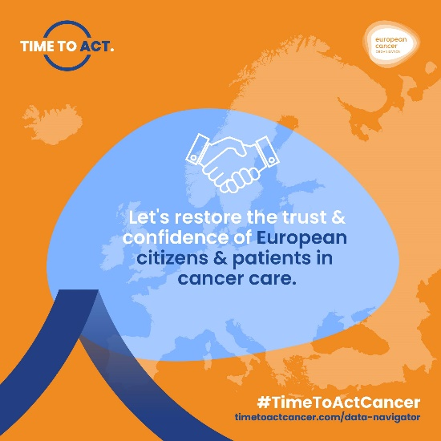
Message 6: We need to ensure timely access to screening and treatment to citizens across Europe | For Facebook and LinkedIn:  Across Europe, #Covid19 has:  🔺disrupted and halted cancer screenings  🔺led to missed cancer diagnoses  🔺decreased cancer treatments and postponed surgeries  This has created a #CancerBacklog and put #CancerPatients at risk❗ Discover the severity of the impact in your country 👉 http://timetoactcancer.com/data-navigator  Let's build a better future for cancer patients by ensuring that timely access to screening 🔎 and treatments💊 is restored!  #TimeToActCancer  For Twitter:  #Covid19 has created a #CancerBacklog and put #CancerPatients at risk❗  Discover the severity of the impact in your country with #DataNavigator👉 http://timetoactcancer.com/data-navigator  📢We need to ensure timely access to screening and treatment to citizens across Europe❗️  #TimeToActCancer | 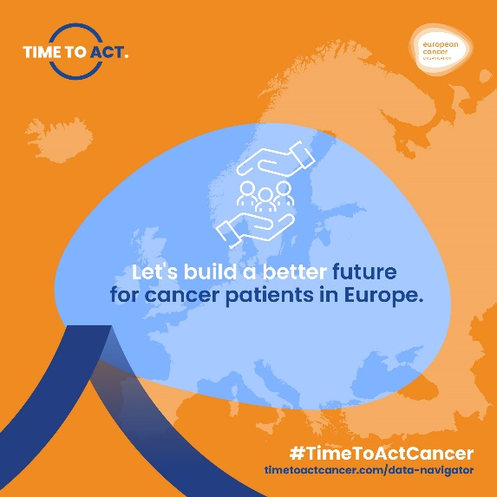
Message 7: We need to ensure cancer care medicines, products, and equipment availability across Europe. | For Facebook and LinkedIn:  The #Covid19 pandemic has tested Europe's medicine supply chains like never before.  Shortages and disruptions🚧 to cancer medicines were but one of the impacts of the pandemic on #CancerCare. The @European Cancer Organisation ’s #DataNavigator highlights more 👉 http://timetoactcancer.com/data-navigator  Together, we need to make sure our supply chains are resilient, helping us restore the confidence of European cancer patients in cancer care delivery post-Covid-19.  For Twitter:  The #Covid19 pandemic impacted Europe's medicine supply chains like never before  The @EuropeanCancer’s #DataNavigator highlights more 👉 http://timetoactcancer.com/data-navigator  📢We need to ensure #CancerCare medicines, products, & equipment availability across Europe  #TimeToActCancer | 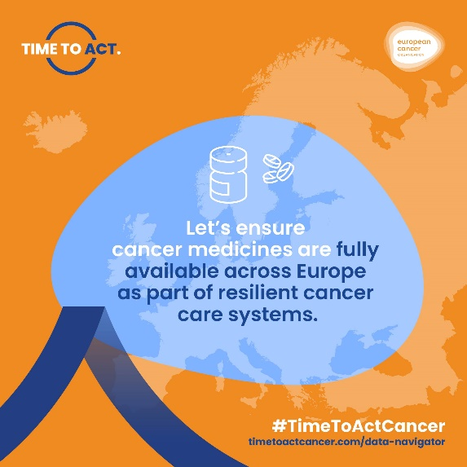
Message 8: It is time to address shortages of cancer care professionals across Europe | For Facebook and LinkedIn:  #HealthcareWorkers⚕️ are a vital part of our healthcare systems, and #Covid19 has shown us how invaluable their work is👏  The pandemic has not only disrupted oncologists’ and #CancerCare professional’s work but also added to the burden of a workforce that was already in short supply❗  Evidence from the @European Cancer Organisation’s #DataNavigator helps better understand the impact of Covid-19 on healthcare workers 👉 http://timetoactcancer.com/data-navigator  It’s #TimeToAct and address the ongoing oncology and health workforce shortage.  For Twitter:  The pandemic added burden to #HealthcareWorkers 👉Already experiencing shortages  📢It's time to address shortages of #CancerCare professionals  @EuropeanCancer’s #DataNavigator helps understand the impact of Covid-19 on healthcare workers in Europe👉 http://timetoactcancer.com/data-navigator | 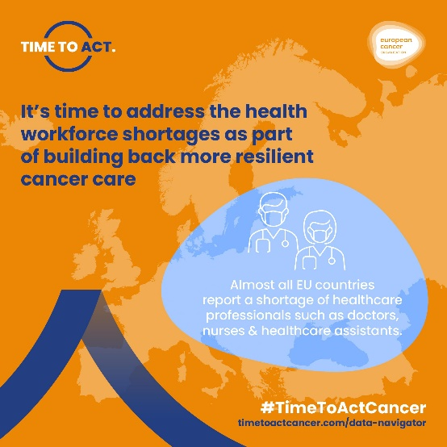
Message 9: We need to improve cancer care professionals’ well-being and working conditions. | For Facebook and LinkedIn:  #Covid19 has put additional strain on #HealthcareWorkers 👩‍⚕️👨‍⚕️⚕️ and their #Wellbeing.  Increased stress, anxiety, and disruptions to their working schedules are just some of the negative effects of the pandemic on healthcare workers across Europe 👉 http://timetoactcancer.com/data-navigator  Improving their working conditions and ensuring their mental🧠 and physical💪 #wellbeing is a key part of building resilient and future-proof healthcare systems.  #DataNavigator #TimeToActCancer  For Twitter:  Stress & anxiety are just some of the negative effects of the pandemic on #HealthcareWorkers across Europe 👉 http://timetoactcancer.com/data-navigator  Better working conditions + mental & physical #wellbeing =🗝️ part of resilient & future-proof #HealthcareSystems  #DataNavigator @EuropeanCancer | 