World Health Worker Week
Social media toolkit for the European Cancer Community

Dear colleague,
World Health Worker Week (1-7 April) is a prime opportunity to highlight the workforce crisis in cancer care that impacts all of us in Europe. Our new social media toolkit is designed to amplify calls for policies and strategies that can effectively address the crisis.
We can no longer wait. We need to act – all of us.
This toolkit includes a variety of pre-crafted social media posts tailored for different platforms, including X (Twitter), Bluesky, Facebook, LinkedIn, and Instagram. These posts highlight key aspects of the Time to Accelerate for our Cancer Workforce campaign and the European Cancer Organisation’s Workforce Report, published last November.
By using this toolkit, you can help spread the word about the European cancer workforce crisis, encouraging more oncology professionals to join in this important call for action.

How to Use This Toolkit
- Select the platform: Choose the social media platform you wish to use.
- Customize if needed: Feel free to tailor the messages to better fit your audience while maintaining the core message.
- Include visuals: Along with this document, you will be able to download visuals. Accompany posts with relevant images or graphics to enhance engagement.
- Use hashtags: Incorporate the suggested hashtags to increase the visibility of the posts.

Our key Hashtags
To ensure that your posts can be monitored throughout the campaign, creating a sense of unity, please use the following hashtags:

#CancerWorkforce | #WHWWeek | #HealthWorkersSaveLives

Our suggested pre-crafted posts
Below, you will find a list of pre-crafted materials that you can use to prepare your social media posts. Feel free to use them as they are, or take inspiration from them, modifying them according to your policies and priorities. The first table gathers eight pre-crafted publications optimised for X and Bluesky, the second table gathers eight pre-crafted publications optimised for LinkedIn and Facebook, and the third one gathers eight pre-crafted publications optimised for Instagram.

X and Bluesky optimised posts
Suggested square visuals can be downloaded here.
Recommended text | Square visual
🔴55% of those in Europe’s #CancerWorkforce say their work feels endless  Crises like Ukraine & COVID19, alongside current staff shortages are taking a toll  On #WHWWeek, we call for urgent action to support European cancer professionals  Learn more👉 https://www.europeancancer.org/resources/publications/under-pressure-safeguarding-the-health-of-europes-oncology-workforce.html  #HealthWorkersSaveLives | 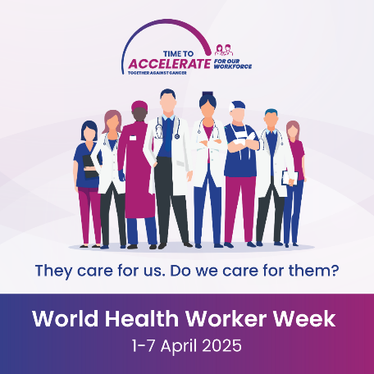
📉Nearly 8% of new cancer professionals plan to leave within 5 years. Low pay, understaffing & burnout are driving them out  On #WHWWeek, we call for a #CancerWorkforce Action Plan with less bureaucracy, fair compensation & professional development  👉https://www.europeancancer.org/resources/publications/under-pressure-safeguarding-the-health-of-europes-oncology-workforce.html  #HealthWorkersSaveLives | 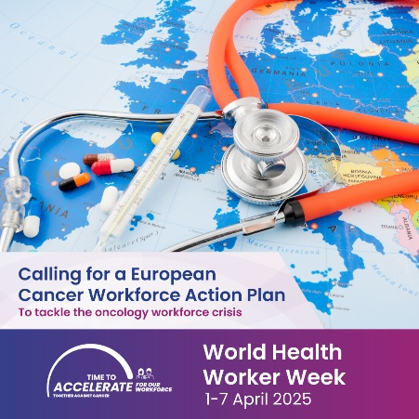
🎓Innovation in health means nothing without trained staff to deliver it to patients  On #WHWWeek, Europe's #CancerWorkforce calls for more EU investment in ongoing training  👉https://www.europeancancer.org/resources/publications/under-pressure-safeguarding-the-health-of-europes-oncology-workforce.html  #HealthWorkersSaveLives | 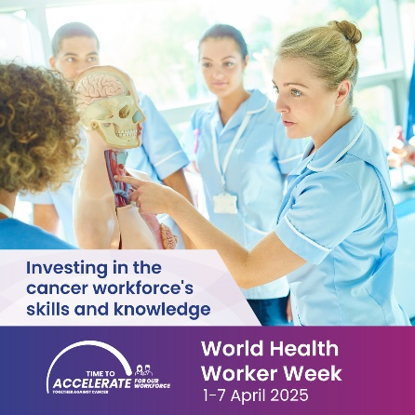
📊 36% of Europe’s oncology professionals are unhappy with their career development  On #WHWWeek, let’s call on Europe’s health system managers to prioritise continuous professional development for the #CancerWorkforce  👉https://www.europeancancer.org/resources/publications/under-pressure-safeguarding-the-health-of-europes-oncology-workforce.html  #HealthWorkersSaveLives | 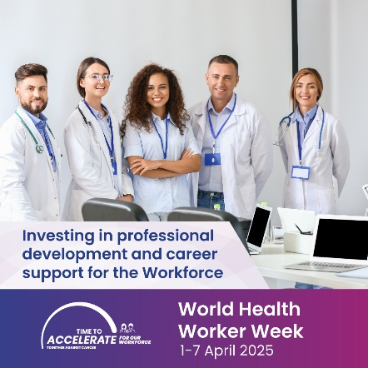
55% of Europe’s #CancerWorkforce say greater bureaucracy is making their jobs harder  On #WHWWeek, we call the @EU_Commission & @Europarl_EN for more digital support throughout cancer care.  👉https://www.europeancancer.org/resources/publications/under-pressure-safeguarding-the-health-of-europes-oncology-workforce.html  #HealthWorkersSaveLives | 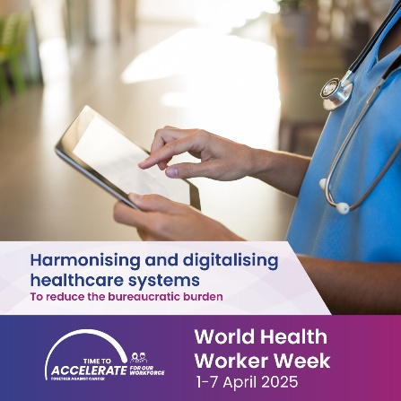
⏰ 70% of the European #CancerWorkforce must work overtime, and not always fairly compensated. This strongly affects patient care  On #WHWWeek, health system managers need to address fair staffing standards  👉https://www.europeancancer.org/resources/publications/under-pressure-safeguarding-the-health-of-europes-oncology-workforce.html  #HealthWorkersSaveLives | 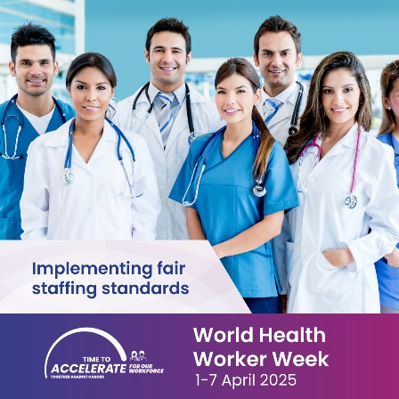
🧠 30% of the European #CancerWorkforce feels anxious about work  On #WHWWeek, national governments must protect the mental & physical health of cancer professionals  👉https://www.europeancancer.org/resources/publications/under-pressure-safeguarding-the-health-of-europes-oncology-workforce.html  #HealthWorkersSaveLives | 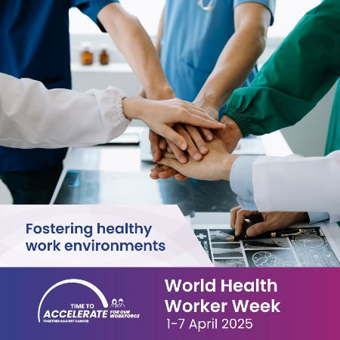
🚨In November, @EuropeanCancer published a  report exposing the crisis facing Europe’s #CancerWorkforce  On #WHWWeek, we renew our call to:  Reduce admin burden  Ensure fair compensation  Support professional growth  👉https://www.europeancancer.org/resources/publications/under-pressure-safeguarding-the-health-of-europes-oncology-workforce.html  #HealthWorkersSaveLives | 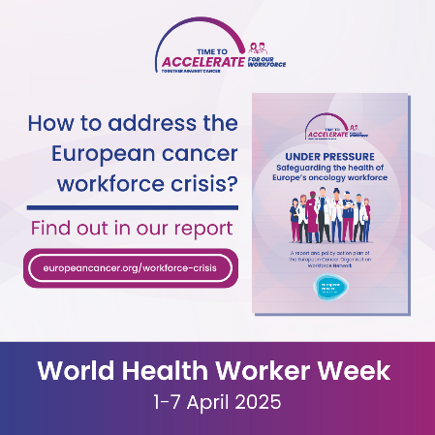

LinkedIn and Facebook optimised posts
Suggested landscape visuals can be downloaded here.
Recommended text | Landscape visual
🔎 55% of cancer professionals in Europe say their work feels ENDLESS.  Ongoing crises — from the war in Ukraine to the aftermath of the Covid-19 pandemic — continue to place an immense strain on healthcare professionals. This pressure, combined with growing shortages across the #CancerWorkforce, is taking a serious toll on those at the frontline of cancer care.  During World Health Worker Week (#WHWWeek), we’re calling for urgent action to address the crisis facing Europe’s cancer workforce.  💡 What can be done? Discover key recommendations here 👉 https://www.europeancancer.org/resources/publications/under-pressure-safeguarding-the-health-of-europes-oncology-workforce.html  #HealthWorkersSaveLives | 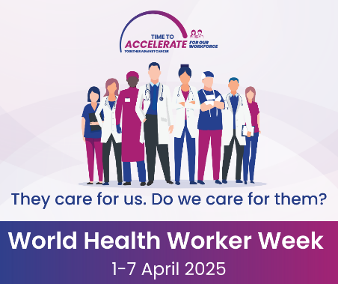
📉 Nearly 8% of cancer professionals in Europe are considering leaving their roles within 1–5 years.  Why? Insufficient staffing, low compensation, and overwhelming workloads are driving them away.  This World Health Worker Week (#WHWWeek), we urge European policymakers, national governments, and health system leaders to take action.  It’s time to develop a Cancer Workforce Action Plan — one that:  ✅ Reduces administrative burdens  ✅ Ensures fair and competitive compensation  ✅ Strengthens continuous professional development  💬 Learn more about the #TimeToAccelerate #CancerWorkforce campaign 👉 https://www.europeancancer.org/resources/publications/under-pressure-safeguarding-the-health-of-europes-oncology-workforce.html  #HealthWorkersSaveLives | 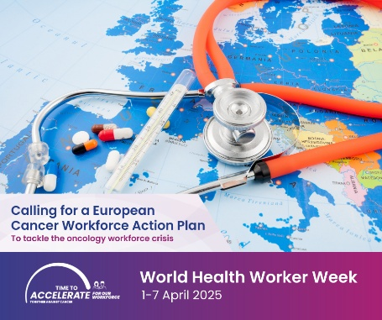
🎓 Ongoing training is essential if the #CancerWorkforce is to deliver the full benefits of healthcare innovation to patients.  During World Health Worker Week (#WHWWeek), we call on the European Commission and European Parliament to prioritise investment in the skills and knowledge of oncology professionals.  We need a comprehensive Cancer Workforce Action Plan — one that ensures patients have access to the latest advances in cancer care and treatment.  🔍 Learn more 👉 https://www.europeancancer.org/workforce-crisis.html  #HealthWorkersSaveLives | 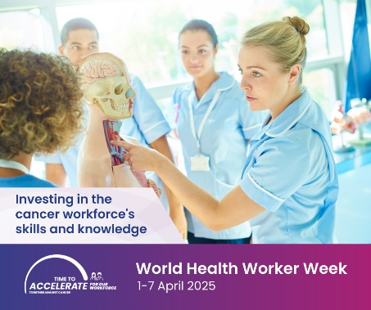
📊 36% of Europe’s #CancerWorkforce is dissatisfied with professional development opportunities.  This World Health Worker Week (#WHWWeek), we call on health system managers across Europe to improve working conditions and support continuous professional development for oncology professionals.  Creating more motivated workers starts with investing in their growth.  🔍 Learn more 👉 https://www.europeancancer.org/resources/publications/under-pressure-safeguarding-the-health-of-europes-oncology-workforce.html  #HealthWorkersSaveLives | 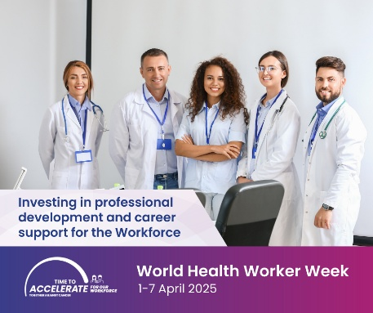
🗂️ 55% of cancer professionals in Europe say that excessive administrative procedures make their work too difficult.  This World Health Worker Week (#WHWWeek), we urge European governments and institutions to work together on a comprehensive Cancer Workforce Action Plan — one that cuts through bureaucracy by embracing smart technologies and digital solutions.  Let’s empower the #CancerWorkforce to focus on what truly matters: patient care.  🔍 Learn more 👉 https://www.europeancancer.org/resources/publications/under-pressure-safeguarding-the-health-of-europes-oncology-workforce.html  #HealthWorkersSaveLives | 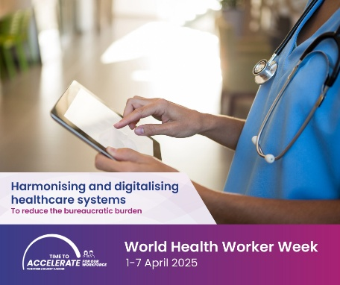
⏰ Over 70% of cancer professionals in Europe must regularly work overtime — often without fair compensation.  This has a direct impact on their performance and wellbeing.  During World Health Worker Week (#WHWWeek), we call on health system managers across Europe to implement fair staffing standards and address unpaid overtime.  The #CancerWorkforce deserves support that matches their dedication.  🔍 Learn more 👉 https://www.europeancancer.org/resources/publications/under-pressure-safeguarding-the-health-of-europes-oncology-workforce.html  #HealthWorkersSaveLives | 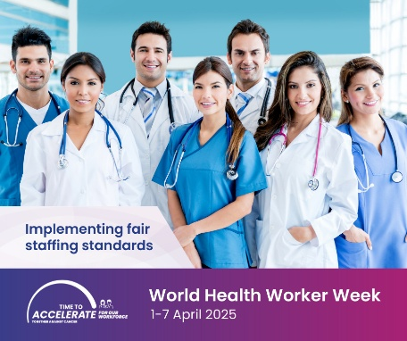
🧠 30% of cancer professionals in Europe report their work is making them anxious.  This World Health Worker Week (#WHWWeek), we call on European governments to join forces with EU institutions to address the #CancerWorkforce crisis – in all its forms.  A comprehensive Cancer Workforce Action Plan is needed — one that safeguards the mental and physical health of oncology professionals.  🔍 Learn more 👉 https://www.europeancancer.org/resources/publications/under-pressure-safeguarding-the-health-of-europes-oncology-workforce.html  #HealthWorkersSaveLives | 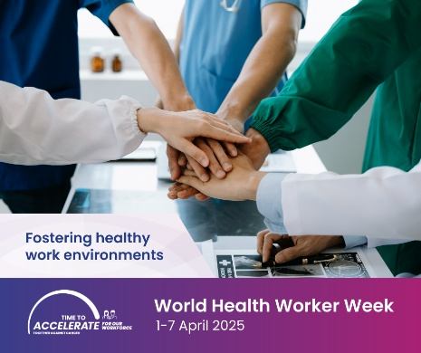
🚨 Last November, the European Cancer Organisation published an alarming report on working conditions of the European #CancerWorkforce. Since then, we’ve been calling for urgent and coordinated action.  This World Health Worker Week (#WHWWeek), we raise our voices once again. It’s time for policymakers and health administrators to deliver a comprehensive Cancer Workforce Action Plan — one that:  ✅ Reduces administrative burden  ✅ Ensures fair compensation  ✅ Supports continuous professional development  This crisis cannot continue.  🔍 Read the full report 👉 https://www.europeancancer.org/resources/publications/under-pressure-safeguarding-the-health-of-europes-oncology-workforce.html  #HealthWorkersSaveLives | 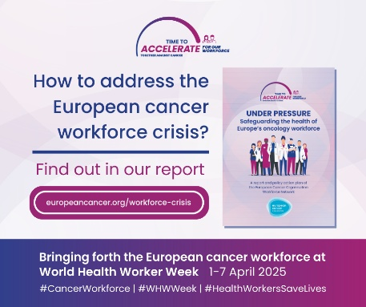

Instagram optimised posts
Suggested portrait visuals can be downloaded here.
Recommended text | Portrait visual
🔎 55% of cancer professionals in Europe say their work feels ENDLESS.  Ongoing crises — from the war in Ukraine to the aftermath of the Covid-19 pandemic — place immense strain on healthcare professionals. This pressure, combined with growing shortages across the #CancerWorkforce, is taking a serious toll on those at the frontline of cancer care.  During World Health Worker Week (#WHWWeek), we’re calling for urgent action to address the crisis facing Europe’s cancer workforce.  💡 What can be done? Discover key recommendations at europeancancer.org/workforce  #HealthWorkersSaveLives | 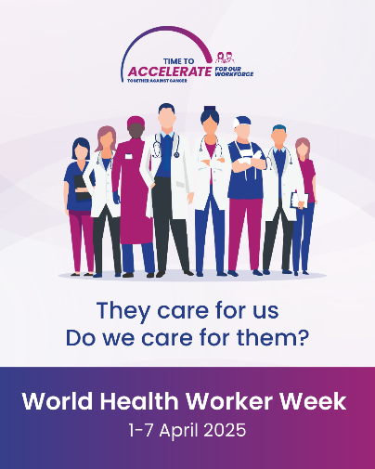
📉 Nearly 8% of cancer professionals in Europe are considering leaving their roles within 1–5 years.  Why? Insufficient staffing, low compensation, and overwhelming workloads are driving them away.  This World Health Worker Week (#WHWWeek), we urge European policymakers, national governments, and health system leaders to take action.  It’s time to develop a Cancer Workforce Action Plan — one that:  ✅ Reduces administrative burdens  ✅ Ensures fair and competitive compensation  ✅ Strengthens continuous professional development  💬 Learn more about the #TimeToAccelerate #CancerWorkforce campaign 👉 europeancancer.org/workforce  #HealthWorkersSaveLives | 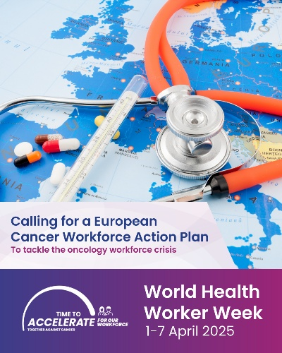
🎓 Ongoing training is essential if the #CancerWorkforce is to deliver the full benefits of healthcare innovation to patients.  During World Health Worker Week (#WHWWeek), we call on the European Commission and European Parliament to prioritise investment in the skills and knowledge of oncology professionals.  We need a comprehensive Cancer Workforce Action Plan — one that ensures dedicated professionals can deliver the latest advances in cancer care and treatment.  🔍 Learn more at europeancancer.org/workforce  #HealthWorkersSaveLives | 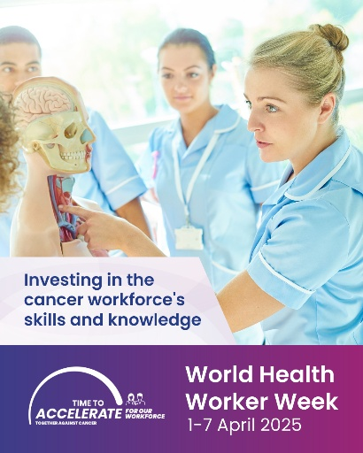
📊 36% of Europe’s #CancerWorkforce is frustrated by the lack of professional development opportunities.  This World Health Worker Week (#WHWWeek), we call on health system managers across Europe to improve working conditions and support continuous professional development for oncology professionals.  Creating more motivated cancer workers starts with investing in their growth.  🔍 Learn more 👉 europeancancer.org/workforce  #HealthWorkersSaveLives | 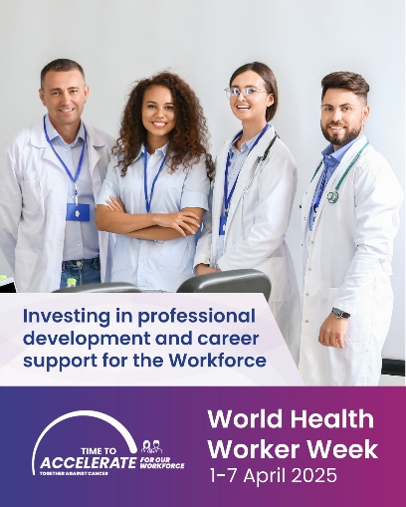
🗂️ 55% of cancer professionals in Europe report excessive administrative procedures.  This World Health Worker Week (#WHWWeek), we urge European governments and EU institutions to work together on a comprehensive Cancer Workforce Action Plan — one that cuts through bureaucracy by embracing smart technologies and digital solutions.  Let’s empower the #CancerWorkforce to focus on what truly matters: patient care.  🔍 Learn more 👉 europeancancer.org/workforce  #HealthWorkersSaveLives | 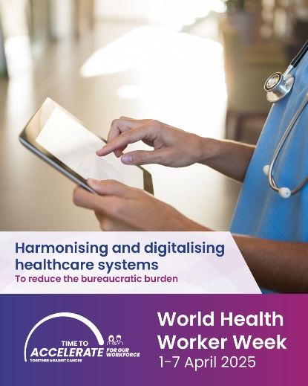
⏰ Over 70% of cancer professionals in Europe must regularly work overtime — often without fair compensation.  This has a direct impact on their performance and wellbeing.  During World Health Worker Week (#WHWWeek), we call on health system managers across Europe to improve working conditions by implementing fair staffing standards and addressing unpaid overtime.  The #CancerWorkforce deserves support that matches their dedication.  🔍 Learn more 👉 europeancancer.org/workforce  #HealthWorkersSaveLives | 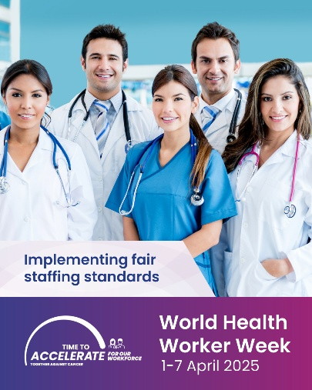
🧠 30% of cancer professionals in Europe say their work is making them anxious.  This World Health Worker Week (#WHWWeek), we call on European governments to join forces with EU institutions to address the #CancerWorkforce crisis.  A comprehensive Cancer Workforce Action Plan is needed — one that safeguards the mental and physical health of oncology professionals.  🔍 Learn more 👉 europeancancer.org/workforce  #HealthWorkersSaveLives | 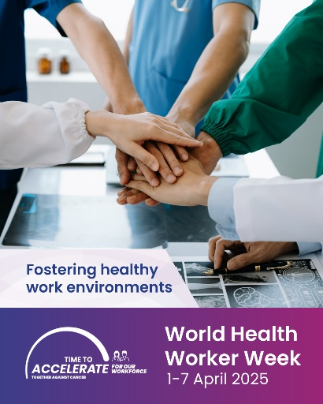
🚨 Last November, the European Cancer Organisation published an alarming report on the working conditions of the European #CancerWorkforce  This World Health Worker Week (#WHWWeek), we call on policymakers and health administrators to deliver a comprehensive Cancer Workforce Action Plan — one that:  ✅ Reduces administrative burden  ✅ Ensures fair compensation  ✅ Supports continuous professional development  This crisis cannot continue.  🔍 Read the full report 👉 europeancancer.org/workforce  #HealthWorkersSaveLives | 

